DRINGEND - BITTE SOFORT AUSLIEFERN! IMPORTANT - DELIVER IMMEDIATELY!
Rapid Alert Notification of a Quality Defect ± Recall
Sender:  <add letter head of sender> |  |  |  |  |  |  |  |  |  | 1. Reference no.:
2. Recall no. assigned:
(if available)
3. To: |  |  | ☐ BfArM |  |  |  | ☐ BVL |  | ☐ PEI |  |  | ☐ OLGB |  |  |  |  | ☐ OLVET
4. Files attached? |  |  |  |  | <please choose>
5. For use in  <please choose> |  |  |  |  |  | 6a. Class of defect <please choose>  6b. Product recall? <please choose> |  |  |  |  |  |  |  |  |  | 7. Reason  <please choose>
 | 8. Product |  |  |  |  | 9. Strength |  |  |  | 10. INN or Generic name |  |  |  |  |  | 11. Pack size and presentation
 | <text> |  |  |  |  | <text> |  |  |  | <text> |  |  |  |  |  | <text>
 | 12. Brand/Trade name |  |  |  |  |  |  | 13. Dosage form |  |  |  |  |  | 14. Marketing authorisation number
 | <text> |  |  |  |  |  |  | <please choose>  <text> |  |  |  |  |  | <text>
 | 15. Batch number(s) and bulk (if different) |  |  |  |  |  |  |  |  | 16. Date(s) manufactured |  |  |  |  | 17. Expiry date(s)
 | <text> |  |  |  |  |  |  |  |  | <dd.mm.yyyy> |  |  |  |  | <dd.mm.yyyy>
18. Marketing authorisation holder |  |  |  |  |  |  |  |  |  | 19. Manufacturer
Name |  | <text> |  |  |  |  |  |  |  | Name | <text>
Address |  | <text> |  |  |  |  |  |  |  | Address | <text>
E-mail |  | <text> |  |  |  |  |  |  |  | E-mail | <text>
Phone |  | <text> |  |  |  |  |  |  |  | Phone | <text>
20. Recalling firm (if different) |  |  |  |  |  |  |  |  |  | 21. Site where the defect occurred (where the defect is attributed to a manufacturing site and if different from 19)
Name |  | <text> |  |  |  |  |  |  |  | Name | <text>
Address |  | <text> |  |  |  |  |  |  |  | Address | <text>
E-mail |  | <text> |  |  |  |  |  |  |  | E-mail | <text>
Phone |  | <text> |  |  |  |  |  |  |  | Phone | <text>
22. Details of the defect/reason for the recall
<text>
23. Information on distribution including exports (type of customer, including parallel distribution/importation)
<text>
24. Action taken by the issuing authority |  |  |  |  |  |  |  |  |  | 25. Proposed action
<text> |  |  |  |  |  |  |  |  |  | <text>
26. Issuing authority
From (issuing authority) |  |  |  | <text> |  |  |  |  |  | Phone |  |  | <text>
Contact person |  |  |  | <text> |  |  |  |  |  | E-mail |  |  | <text>
Signature
27. Date/Time

This is intended only for the use of the party to whom it is addressed and may contain information that is privileged, confidential, and protected from disclosure under applicable law. If you are not the addressee, or a person authorized to deliver the document to the addressee, you are hereby notified that any review, disclosure, dissemination, copying, or other action based on the content of this communication is not authorized. If you have received this document in error, please notify us by telephone immediately and return it to us at the above address by mail. Thank you.

Anlage 1: Erläuterungen zum Ausfüllen des RAN-Formblattes (vor Versand zu löschen)

Das gesamte Formblatt soll klar verständlich in englischer Sprache ausgefüllt werden. Liegen noch nicht alle Informationen vor, empfiehlt es sich für die Felder, die einen <Text>-Platzhalter haben, diesen mit eine Leerzeichen auszufüllen. So kann vermieden werden, dass <Text> beim Drucken als Wort zu lesen ist.

‚Sender‘: Angabe der meldenden Stelle; Der Briefkopf der absendenden Behörde kann zusätzlich auch in der Kopfzeile des Formulars eingefügt werden.

1. ‚Reference no.‘: Angabe der gem. Kap. 3.2 der VAW generierten Referenznummer zur eindeutigen Identifizierung der RAN

2. ‚Recall no. assigned‘: Sollte dem zugrundeliegenden Fall eine Rückrufnummer zugeordnet worden sein, ist diese hier anzugeben.

3. Empfänger (‚to‘): Innerhalb Deutschlands wird eine RAN an die Bundesoberbehörden (BfArM, BVL, PEI) über die Obersten Landesbehörden verteilt. Die Empfänger sind durch Auswahl der entsprechenden Felder anzugeben. Die Weiterleitung außerhalb Deutschland erfolgt durch die BOB.

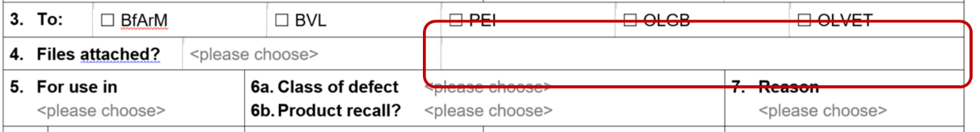
4. ‚Files attached?‘: Enthält die RAN Anhänge, ist dies durch Auswahl ‚yes/no‘ im Dropdown-Feld anzugeben. Anhänge selber können daneben hochgeladen werden:

Über <Einfügen> und <Objekt> kann z. B. ein PDF angehängt werden. Bei der Auswahl des Objekts empfiehlt es sich, die Auswahl ‚als Symbol anzeigen‘ zu aktivieren:
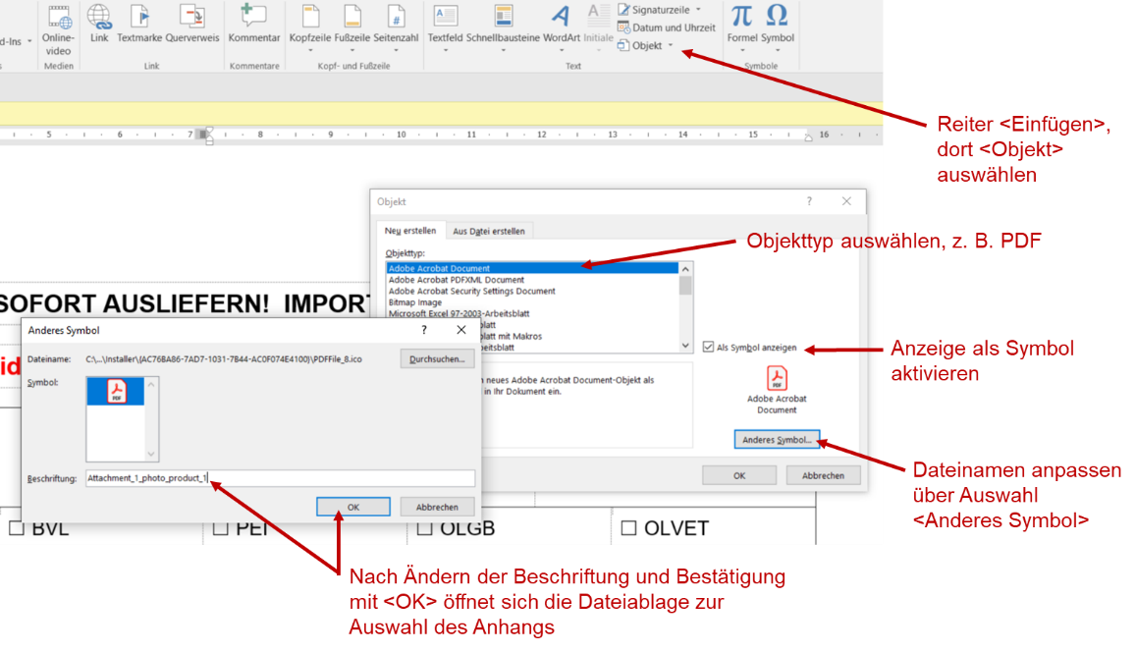

5. ‚For use in‘: Angabe des Anwendungsbereichs des betroffenen Produkts; Auswahl von ‚human‘, ‚veterinary‘ oder ‚human & veterinary im Dropdown-Feld

6a. ‚Class of defect‘: Angabe der Rapid-Alert-Klasse; Auswahl von ‚I‘, ‚II‘ oder ‚not classified‘ im Dropdown-Feld

6b. ‚Product recall‘: Angabe, ob mit der RAN ein Rückruf verbunden ist; Auswahl ‚yes/no‘ im Dropdown-Feld

Hinweis: Ist ein Rückruf aus anderen Gründen als der Einstufung als RA-Klasse I/II erforderlich, ist unter 6a ‚not classified‘ und unter 6b ‚yes‘ auszuwählen

7. ‚Reason‘: Angabe des Grunds, aus dem die jeweilige RAN erstellt wird; Auswahl ‚quality defect‘, ‚falsification‘ oder ‚fraud‘ im Dropdown-Feld

In den nachfolgenden Feldern 8.-17. werden Angaben zu jeweils einem Produkt gemacht (auch mehrere Chargen desselben Produkts). Sind verschiedene Produkte betroffen, können die Felder 8.-17. für jedes Produkt generiert werden. Dazu in eines der Felder klicken, unten rechts erscheint ein Plus, über das die Felder für Angaben zu beliebig vielen Produkte hinzugefügt werden können:
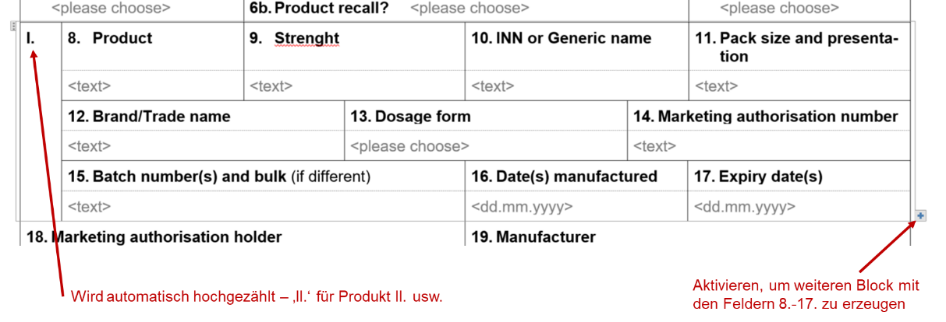

8. ‚Product‘: Bezeichnung des Produkts

9. ‚Strength‘: Stärke des Produkts

10. ‚INN‘: INN-Name

11. ‚Pack size and presentation‘: Packungsgröße

12. ‚Brand/Trade name‘: Markenname/Handelsname

13. ‚Dosage Form‘: Darreichungsform; Auswahl aus einer von der EMA vorgegebenen Liste im Dropdown-Feld

14. ‚Marketing authorisation number‘: Zulassungsnummer

15. ‚Batch no. (and bulk, if different)‘: Chargen-Bezeichnung (und Bulk, falls abweichend); anzugeben sind alle betroffenen Chargen eines Produkts

16. ‚Date manufactured‘: Herstellungsdatum

17. ‚Expiry Date‘: Verfalldatum

18. ‚Marketing authorisation holder‘: Zulassungsinhaber

19. ‚Manufacturer‘: Hersteller

20. ‚Recalling firm‘: für den Rückruf verantwortliche Firma

21. ‚Site where the defect occured‘: Firma/Einrichtung, in der der zugrundeliegende Mangel entdeckt wurde; nur anzugeben, wenn der Defekt bei einem Hersteller auftrat, der nicht der Hersteller nach Nr. 19 ist

22. ‚Details of the defect/reason for the recall‘: Beschreibung des Mangels/Begründung für den Rückruf; wird für eine bereits mit einer vorherigen RAN kommunizierte Charge ein weiterer Rückruf erforderlich, ist dies hier zu vermerken (“Rapid Alert following original rapid alert #ref. no.#”.)

23. ‘Information on distribution including exports (type of customer, including parallel distribution/importation)’: Vertriebswege, einschließlich des Exportes (bes. in MRA-Partnerstaaten)

24. ‚Action taken by the issuing authority’: Maßnahmen der ausstellenden Behörde

25. ‚Proposed Action‘: vorgeschlagene Maßnahmen

26. ‚Issuing Authority‘: Angabe der die RAN ausstellenden Behörde inkl. Ansprechpartner mit Telefonnr., E-Mail-Adresse und Unterschrift (auch elektronisch möglich)

27. ‚Date/Time‘: Datum/Zeit

